Components
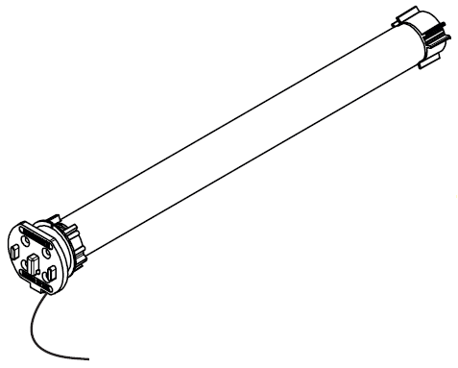
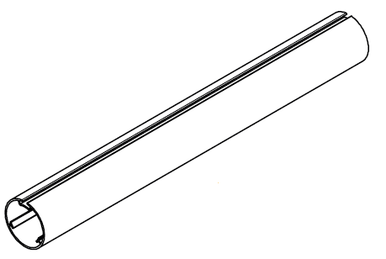
35mm tube
25mm Lithium
Rechargeable Motor
Idle end

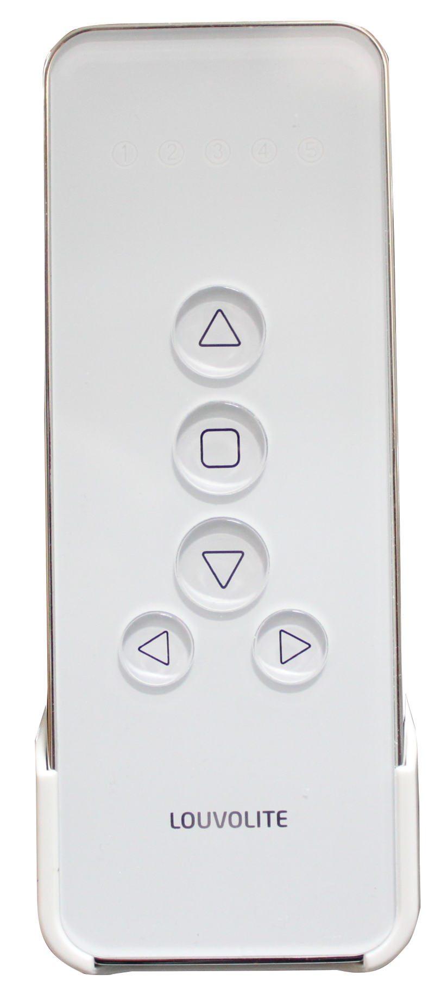

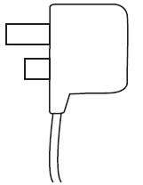
5 channel remote control
Brackets
Charger

To set bottom limit
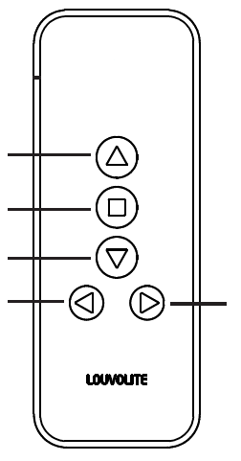
- Press and hold LIMIT button on the back of the remote.
Motor jogs 2 times, then jogs 3 times.
Channel -
Up
Down
Stop
Channel +
Channel #
- Release the button.
Motor is ready to set limits
- Press DOWN button on the remote.
Motor runs down
- Press STOP button when motor gets close to the
end-point of lower limit.
Motor stops
- Press DOWN button.
Motor runs step by step to set lower limit accurately
- Press CONFIRM button on the remote.
The motor jogs 2 times. The setting has completed
To set Upper limit
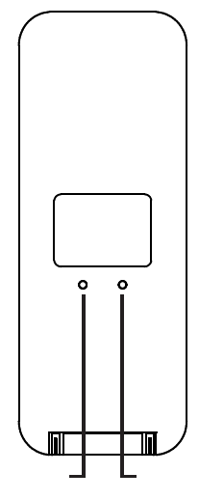
- Press UP button on the remote.
Motor runs up
Confirm
Limit

C L
- Press STOP button when the motor is running close to the
upper stop point.
Motor stops
- Press UP button
Motor runs step by step to adjust upper limit accurately
- Press CONFIRM button on the remote. Motor jogs 2 times.
The setting has completed

To set mid point limit
- Press UP or DOWN button on the remote then press STOP when
desired mid-point height is reached.
Motor runs up or down
- Press and hold LIMIT button first then whilst holding LIMIT press
UP button on the remote.
Hold both buttons until motor jogs.
Mid-point is now set
- To move blind to midpoint position press STOP.
Motor runs up or down to mid-point if not already at mid-point
Pairing remote control with the motor
The remote and motor will be paired during the manufacturing process. Should you need to pair the remote again or add an additional remote control, please follow the instructions below.
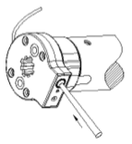
- Hold down the SETTING button on the motor mount
Motor jogs 2 times
- Please release this button when the motor jogs
- Press the CONFIRM button on the remote within 10 seconds
Motor jogs 2 times.
Remote has now been paired with the motor

To delete the original setting on the motor
- Press and hold SETTING button on the motor mount
The motor will jog 2 times firstly, then jog 3 times
- Release the button.
All the records have been deleted - motor reset
Confirm
Limit

C L

Changing motor rotation direction
- Press UP button.
If blind goes up the motor direction is ok. If the blind goes down then the motor direction should be changed.
- While the fabric is moving, hold down LIMIT button and then press STOP button on the remote transmitter
- Hold both buttons until motor jogs. This signifies the motor rotation direction has been changed

FAQ
The motor works with Li-ion battery, please charge when the motor stops working or falters using the charger supplied. Charging time: 5 to 6 hours.
If the motor does not work, charge the motor battery first.
If the motor does not stop at the required point, then the stops must be reset.

